## **Comprehensive Digital Marketing Strategy for Mother Dairy**

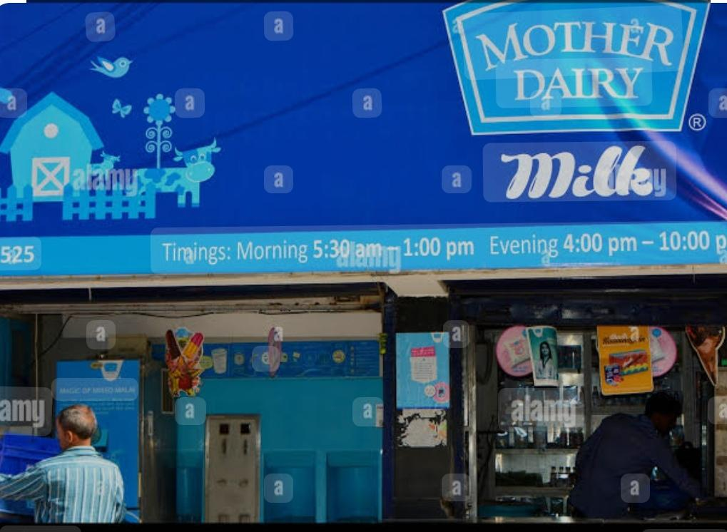

This strategy covers a **brand study, competitor analysis, and buyer personas** to position **Mother Dairy** as a leader in the dairy industry through digital marketing.

# **1. Brand Study of Mother Dairy**

### **Brand Overview**

Mother Dairy is one of India’s leading dairy brands, known for its **milk, ice creams, dairy products, fruits, vegetables, and edible oils**. The brand is recognized for its **quality, trust, and affordability** and is a significant player in the FMCG sector.

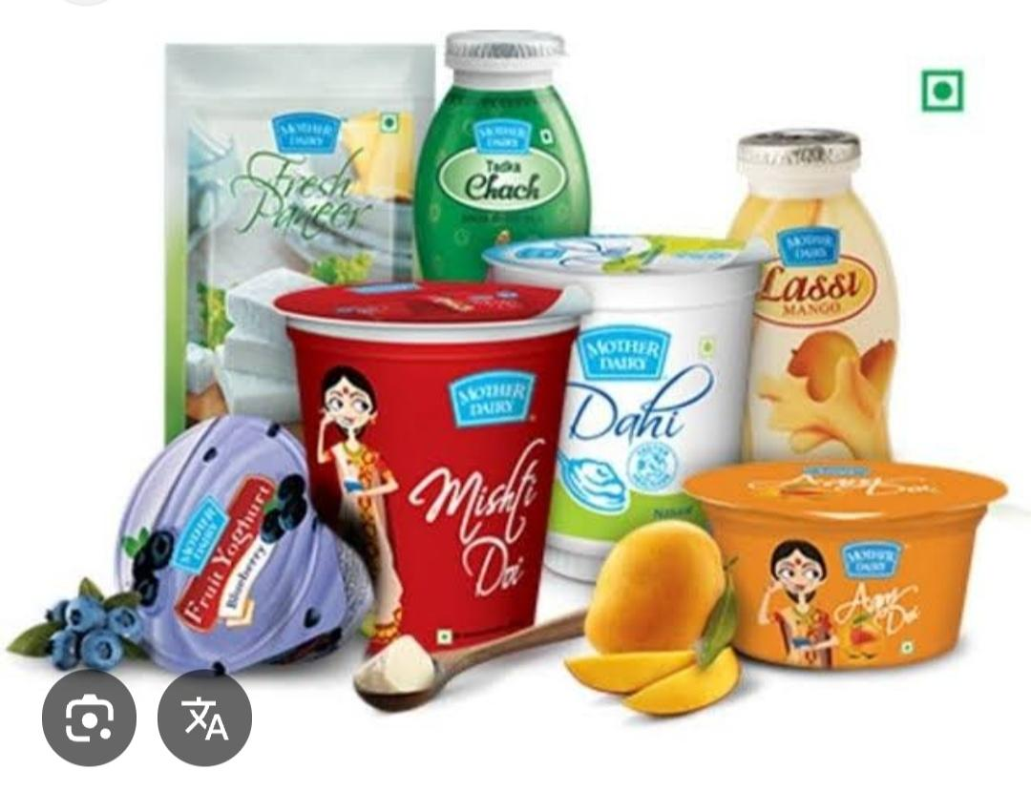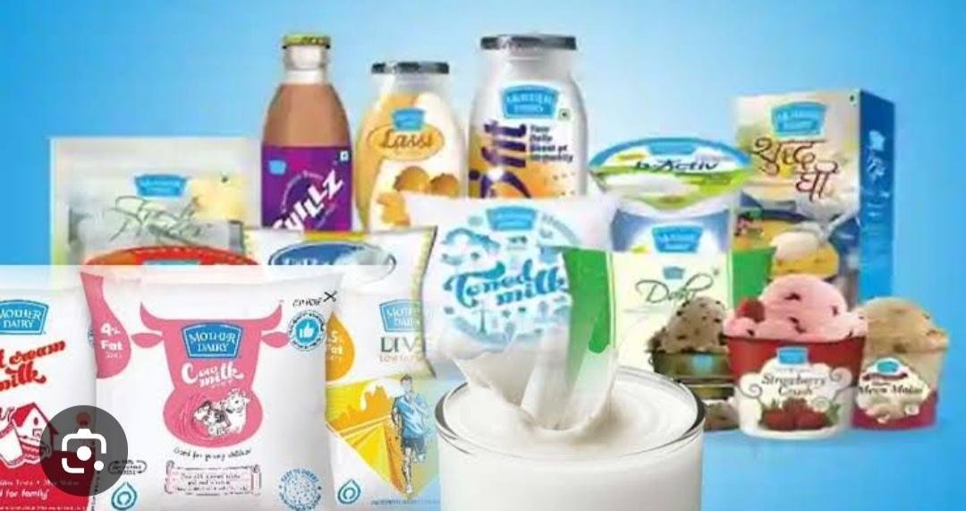

### **Brand Strengths**

* **Established Trust:** Strong brand reputation built over decades
* **Diverse Product Range:** Dairy, beverages, frozen foods, and fresh produce
* **Extensive Distribution:** Availability in retail stores and online platforms
* **Government Support:** Backed by the National Dairy Development Board (NDDB)
* **Sustainability Focus:** Promotes farmer welfare and ethical sourcing

### **Brand Weaknesses**

* **Limited Premium Product Range:** Less focus on organic and premium dairy segments
* **Digital Presence Could Be Stronger:** Compared to new-age brands, digital engagement is moderate
* **Regional Competition:** Strong competition from local dairy brands

# **2. Competitor Analysis**

Direct Competitors

***Amul (Gujarat Cooperative Milk Marketing Federation - GCMMF)***

Market Position: The biggest dairy brand in India, well known for its strong branding and extensive product portfolio.

Products: Milk, butter, cheese, paneer, ice creams, chocolates, dairy beverages.

**Strengths:**

Strongest brand recall in India.

Extensive product variety across all dairy categories.

Aggressive pricing and distribution network across rural and urban India.

Iconic advertising campaigns (Amul Girl, witty marketing).

**Weaknesses:**

Supply chain issues due to high demand fluctuations.

Focus on affordability over premium products, missing the organic and health-conscious segment.

***B. Nestlé India (Dairy Division)***

Market Position: A global FMCG giant with a significant presence in dairy through products like Nestlé Milk, Everyday Dairy Whitener, and a strong hold in infant nutrition.

Products: Milk, yogurt, dairy-based beverages, infant formula, coffee-based dairy drinks.

**Strengths:**

Premium brand perception compared to Indian dairy companies.

Strong presence in value-added dairy products like flavored milk, yogurt, and coffee-based dairy beverages.

Extensive R&D and innovation capabilities.

**Weaknesses:**

Higher pricing limits affordability for mass consumers.

Limited fresh milk and bulk dairy products compared to Mother Dairy and Amul.

***C. Parag Milk Foods (Gowardhan, Go, Pride of Cows, Topp Up)***

Market Position: One of India's fastest-growing dairy companies with a focus on premium dairy and value-added products.

Products: Milk, cheese, butter, ghee, whey protein, flavored milk.

**Strengths:**

Strong cheese market presence with "Go Cheese".

Premium offerings like "Pride of Cows" farm-fresh milk.

Focus on fitness and protein-based dairy products (Avvatar Whey Protein).

**Weaknesses:**

Lower brand recall compared to Amul and Mother Dairy.

Weaker supply chain in rural areas.

***D. Nandini (Karnataka Milk Federation - KMF)***

Market Position: A dominant dairy brand in South India, especially Karnataka.

Products: Milk, butter, cheese, paneer, curd, ghee.

**Strengths:**

Strong regional dominance in Karnataka and expanding in South India.

Competitive pricing compared to other brands.

**Weaknesses:**

Limited presence in North & West India.

Moderate digital marketing efforts

## **Indirect Competitors**

1. **Plant-based Milk Brands:** Epigamia, Sofit, Raw Pressery (Targeting health-conscious consumers)
2. **Local Dairy Farms:** Fresh milk delivery startups gaining traction in metro cities

### **Key Takeaways from Competitor Analysis**

1. **Amul leads in digital marketing**, particularly with witty and viral content.
2. **Nestlé is strong in premium segments** and has excellent global credibility.
3. **Parag Milk Foods is expanding aggressively** in niche categories like cheese.
4. **Mother Dairy can focus on digital storytelling, sustainability, and premium products** to differentiate itself.

# **3. Buyer Persona for Mother Dairy**

## **Primary Target Audience Segments**

### **A. Health-Conscious Urban Mothers**

**\*Age:** 28-45

**\*Location:** Metro & Tier-1 cities

**\*Pain Points:** Concerned about nutrition, adulteration, and quality of dairy products

**\*Digital Behavior:** Active on Instagram, Facebook, and WhatsApp; reads health blogs

**\*Marketing Strategy:** Influencer marketing, recipe videos, nutrition-focused ads

### **B. Millennials & Young Professionals**

**\*Age:** 22-35

**\*Location:** Metro & Tier-2 cities

**\*Pain Points:** Prefers quick, healthy, and convenient dairy options

**\*Digital Behavior:** Engages with Instagram reels, food delivery apps, and e-commerce

**\*Marketing Strategy:** Ads on Swiggy/Zomato, fun and engaging content, collaborations with food bloggers

### **C. Traditional Families & Senior Citizens**

**\*Age:** 45+

**\*Location:** Tier-2 & Tier-3 cities, rural areas

**\*Pain Points:** Brand loyalty, preference for trusted products, affordability

**\*Digital Behavior:** Uses YouTube, WhatsApp forwards, and local news sites

**\*Marketing Strategy:** Emotional storytelling, WhatsApp marketing, regional-language content

### **D. Retailers & Distributors**

**\*Pain Points:** Demand for competitive pricing, reliable supply chain

**\*Digital Behavior:** Active on LinkedIn, business forums, and WhatsApp groups

**\*Marketing Strategy:** B2B campaigns, LinkedIn ads, special discount programs

If you're doing SEO and keyword research for "Mother Dairy," you'll want to focus on keywords related to dairy products, milk, ice cream, and other offerings. Here’s a step-by-step approach:

### **4. Keyword Research for Mother Dairy**

Start by identifying primary, secondary, and long-tail keywords related to Mother Dairy.

#### **Primary Keywords (High Volume)**

* Mother Dairy
* Mother Dairy milk
* Mother Dairy products
* Mother Dairy near me
* Mother Dairy ice cream

#### **Secondary Keywords (Supporting Keywords)**

* Best dairy products in India
* Fresh milk brands
* Mother Dairy franchise
* Mother Dairy outlet
* Mother Dairy butter & ghee

#### **Long-Tail Keywords (Specific & Less Competitive)**

* Mother Dairy full cream milk price
* Where to buy Mother Dairy ice cream
* Best milk for tea and coffee in India
* Mother Dairy vs Amul comparison
* Is Mother Dairy milk good for health?

### **5. SEO Strategy for Mother Dairy**

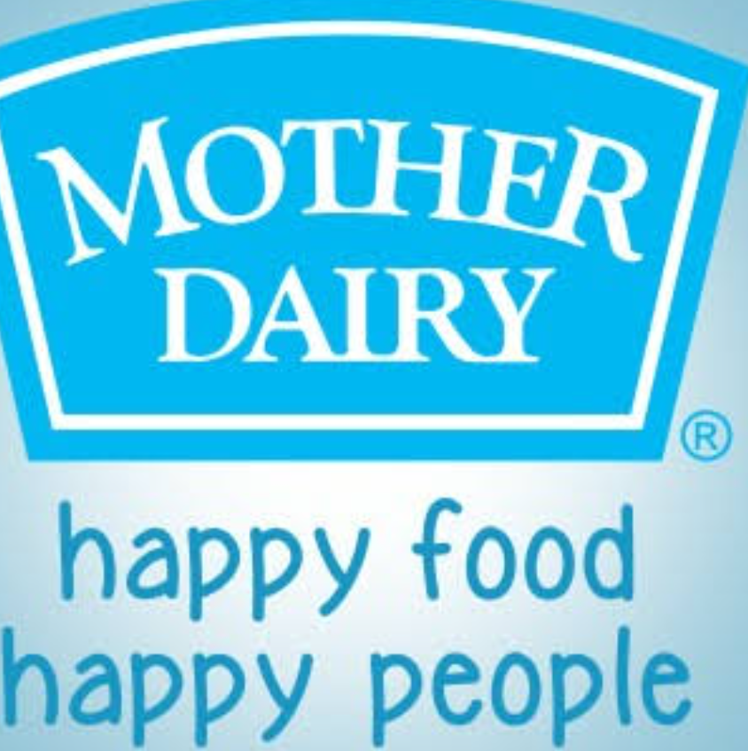

#### **On-Page SEO**

* Optimize product pages with keyword-rich titles, meta descriptions, and headings.
* Use structured data (schema markup) for local SEO.
* Add high-quality images with alt text.
* Internal linking to different dairy products and blog content.

#### **Content Marketing**

* Create blogs like:
  + “Health Benefits of Mother Dairy Milk”
  + “Best Ice Cream Flavors by Mother Dairy”
  + “How to Get a Mother Dairy Franchise in India”
* Use FAQs with structured data to answer common questions.

#### **Technical SEO**

* Improve website speed and mobile responsiveness.
* Use HTTPS for security.
* Optimize for voice search (e.g., “Where is the nearest Mother Dairy booth?”).

#### **Local SEO**

* Optimize Google My Business (GMB) for "Mother Dairy near me" searches.
* Get customer reviews and update GMB regularly.
* Target local keywords like "Mother Dairy outlet in Delhi."

#### **Link-Building**

* Get backlinks from food bloggers and news sites.
* List Mother Dairy on local business directories.

# **6. Digital Marketing Strategy for Mother Dairy**

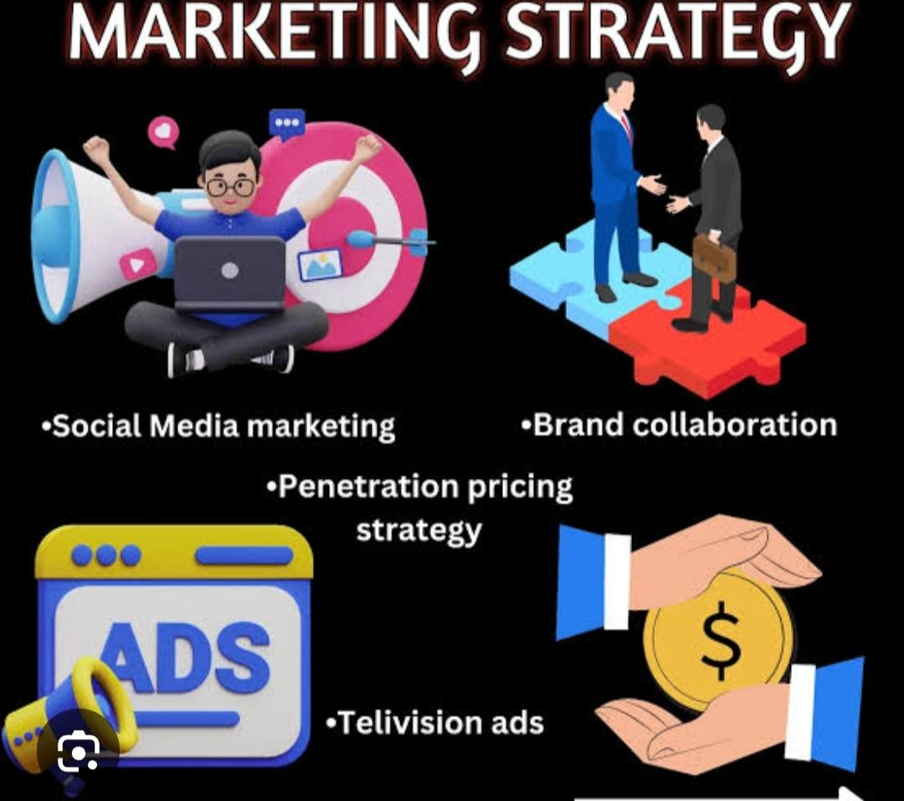

### **1. Website & SEO Optimization**

* Create an SEO-driven blog with topics like **"Best milk for kids"**, **"Is A2 milk better?"**, etc.
* Improve mobile UX and add an online store for **direct-to-consumer sales**
* Use **voice search SEO** as many buyers search in local languages

### **2. Social Media Marketing**

* **Instagram & Facebook:** Fun reels, contests, behind-the-scenes of dairy production
* **YouTube:** Explainers on **dairy nutrition, farmer stories, and product benefits**
* **LinkedIn:** B2B campaigns for distributors and corporate tie-ups

### **3. Content & Influencer Marketing**

* Partner with **mom bloggers, fitness influencers, and chefs**
* Publish **recipe videos and live Q&A sessions on nutrition**
* Share **customer stories and testimonials**

### **4. Paid Advertising Strategy**

* **Google Ads:** "Best dairy products near me," "pure milk brands in India"
* **Facebook & Instagram Ads:** Target urban moms and young professionals
* **YouTube Ads:** Short product explainer videos

### **5. WhatsApp & Email Marketing**

* Personalized WhatsApp messages with **discounts and dairy tips**
* Email newsletters on **seasonal offers and health benefits**

### **6. E-commerce & Online Grocery Strategy**

* Stronger partnerships with **Amazon, BigBasket, Blinkit, and Swiggy Instamart**
* Exclusive **combo deals and subscription models**

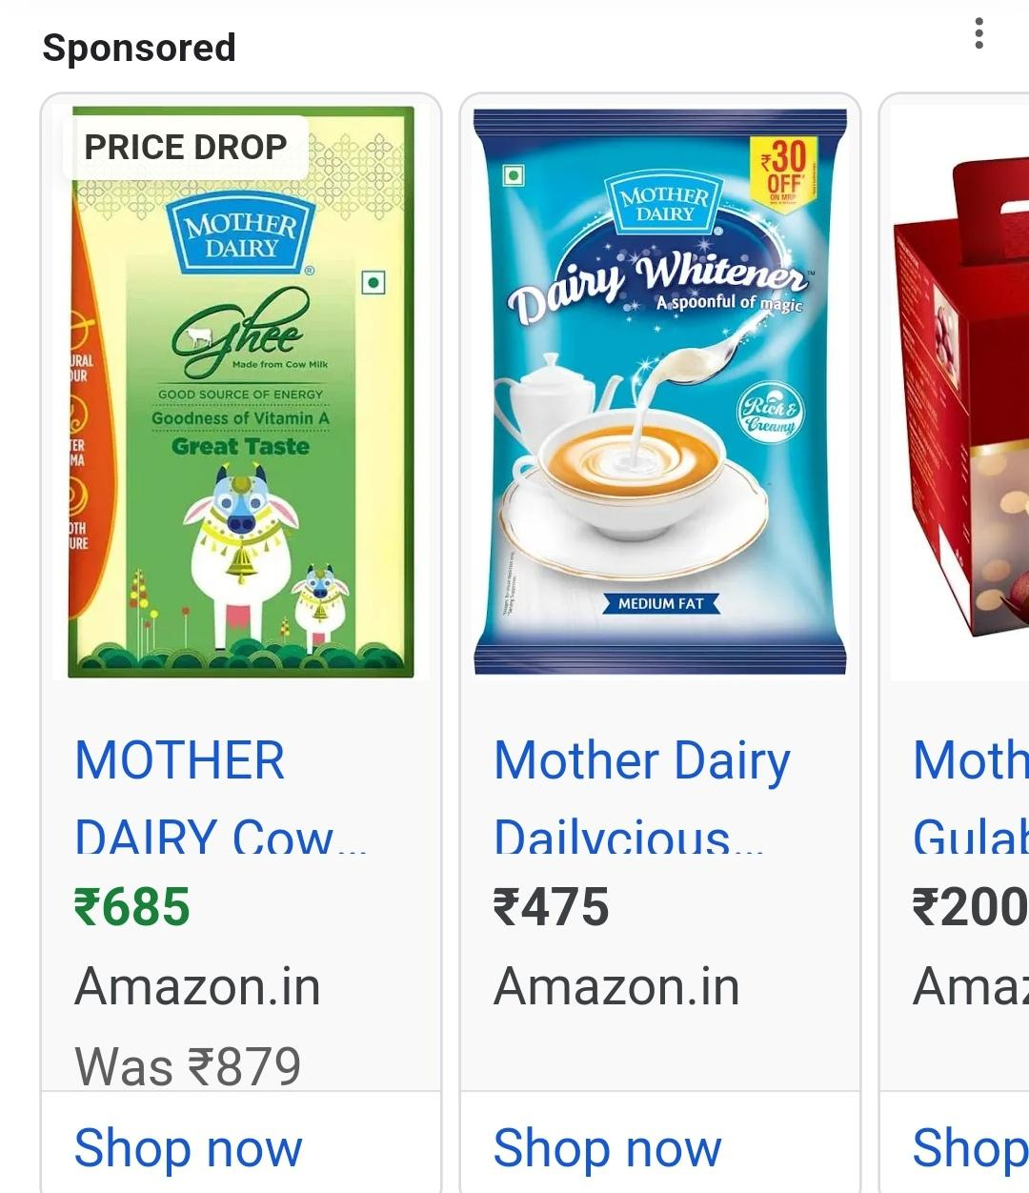

For content creation and curation related to Mother Diary

1. Define Your Theme & Purpose

What is Mother Diary about? (Personal stories, parenting tips, emotional reflections, motherhood journey, etc.)

Who is your target audience? (Mothers, expecting parents, families, etc.)

What emotions or messages do you want to convey?

2. Content Creation Ideas

Personal Stories: Share real-life experiences of motherhood.

Motherhood Reflections: Thoughts on love, sacrifice, and parenting.

Daily Life Moments: Funny, heartwarming, or challenging moments.

Parenting Tips: Advice on raising children, self-care, and balancing life.

Poems & Quotes: Short emotional or motivational content.

Letters to Children: A heartfelt format of writing from a mother to her child.

Interviews: Feature other mothers, grandmothers, or experts.

3. Content Curation (Finding & Organizing Relevant Content)

Curate Stories: Collect and organize inspiring motherhood stories.

Reshare Authentic Content: Find meaningful posts from blogs, books, or social media.

Create Thematic Collections: (e.g., "Motherhood & Mental Health," "Single Mom Stories")

Use Visuals: Include images, videos, or infographics.

Collaborations: Partner with mom bloggers, writers, or influencers.

4. Platforms & Distribution

Blog or Website: Long-form storytelling.

Social Media (Instagram, Facebook, Pinterest, etc.): Short, engaging posts with visuals.

YouTube or Podcast: Audio-visual storytelling.

Newsletter: Send curated content to subscribers.

Would you like specific help with writing, structuring, or promoting your project?

**Final Thoughts & Recommendations**

* **Mother Dairy should enhance digital storytelling** with farmer stories and ethical sourcing campaigns.
* **Launch premium product lines (A2 milk, high-protein dairy) targeting millennials & fitness enthusiasts.**
* **Leverage influencer marketing aggressively** to build trust among urban audiences.
* **Strengthen WhatsApp & e-commerce marketing** for direct consumer reach.